ThinkPad E15 Hotkey Driver Fix Guide August 28, 2026. Dominic Sykes
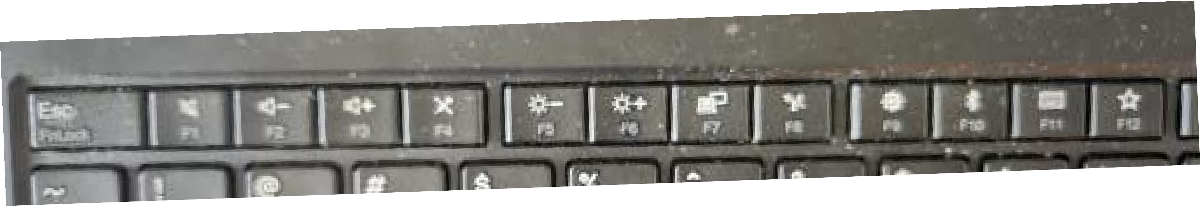
I know these work without FN button being on. Like F9 would open up settings? What happened? I know a few years ago I had reinstalled windows 10 and then upgraded to 11 sometime after. Why won't they work now?
When you reinstalled Windows, the generic OS installation wiped out the manufacturer's proprietary keyboard driver/utility that intercepts those special hotkey shortcuts.
Without the manufacturer's background software running, your system defaults to standard Function key behaviors (F1–F12) rather than media/action key functions, or your Fn Lock state got toggled.
Quick Toggle Fixes
Fn Lock: Press Fn + Esc (your Esc key shows FnLock under it). This toggles the top row between standard F1–F12 inputs and media hotkeys.
BIOS/UEFI Setting: Restart your PC, enter the BIOS setup (usually pressing F2 or Del at startup), and look for Action Keys Mode or Function Key Behavior to set media keys as default.
The Permanent Software Fix
Because shortcuts like F9 opening Settings or F10 toggling Bluetooth rely on vendor-specific software (common on Lenovo, Dell, HP, or ASUS systems), you need to reinstall that specific control utility.
Identify Manufacturer: Check your laptop brand (e.g., Lenovo Vantage, HP System Event Utility, Dell Peripheral Manager, or ASUS Armoury Crate/MyASUS).
Download Utilities: Go to the manufacturer's official support page for your laptop model and download their Hotkeys Driver or System Control Interface.
Windows Update: Go to Settings > Windows Update > Advanced Options > Optional Updates and check for driver updates related to system firmware or keyboard utility drivers.
Okay. How to find laptop model? Command Prompt / PowerShell
Press Win + R, type cmd, and press Enter.

Type wmic csproduct get name or Get-CimInstance -ClassName Win32_ComputerSystem | Select-Object Model and press Enter.
System Information Tool
Press Win + R, type msinfo32, and press Enter.
Look for System Model and System Manufacturer in the main summary tab. Windows Settings
Go to Settings > System > About.
Check near the top of the page under the device name card for your specific model number. Physical Labels
Check the bottom chassis of the laptop for a sticker detailing the model number and serial number.
If the battery is removable, check inside the battery compartment underneath the battery pack. System Model 20RD006CUS manufacturer website
Your model number 20RD006CUS corresponds to a Lenovo ThinkPad E15 (Type 20RD).
To get your custom F1–F12 hotkey functionality back (like F9 opening Settings or F10 managing Bluetooth), you need to reinstall Lenovo's management software and hotkey drivers.
How to Fix It
Download Lenovo Vantage: Open the Microsoft Store on your PC, search for Lenovo Vantage, and install it. This app restores background control for your function keys and system settings.
Official Drivers Page: Visit the Lenovo ThinkPad E15 (Type 20RD) Drivers & Software Page.
Install System Update & Hotkeys: Under the Software and Utilities section on that page, download and install the Lenovo Hotkey Features Integration driver (or run Automatic Driver Update on their site).
Once installed, restart your laptop and the special top-row shortcuts will work again automatically.

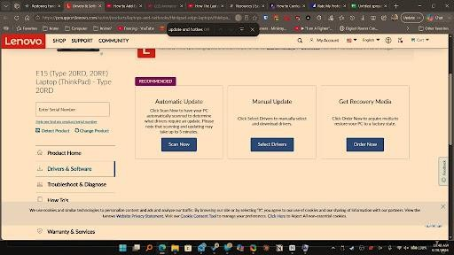
download what?
Click the Select Drivers button under the Manual Update tile in the middle of your screen. Once the driver categories expand:
Click on Software and Utilities.
Find Lenovo Hotkey Features Integration (or Lenovo Fn and Function Keys). Click Download, then open and run the .exe file once it finishes downloading.
Alternative: You can also just click Scan Now under Automatic Update to let Lenovo detect and install any missing drivers automatically.
software and utilities button not there
Step 1: On the screen you are currently looking at, click the blue Select Drivers button inside the Manual Update tile.
Step 2: On the page that opens next, scroll down to the category list and click on Software and Utilities.
Step 3: Look for Lenovo Hotkey Features Integration (or Lenovo Base Utility). Click the download arrow next to it, then run the installer file once downloaded.
Easier Alternative: If you don't want to navigate through the manual driver list, click the blue Scan Now button under Automatic Update on the screen you currently have open. It will scan your ThinkPad E15 and automatically install the missing hotkey drivers for you.
Lenovo Service Bridge wont open

Skip Lenovo Service Bridge entirely—it often gets blocked by Windows security or browser settings.
You can bypass it completely using either of these two methods:
Method 1: Direct Microsoft Store App (Fastest) Open the Microsoft Store on your ThinkPad.
Search for Lenovo Hotkeys (or Lenovo Vantage).
Click Get or Install. This app handles all top-row F1–F12 hotkey functions natively on Windows 11.
Method 2: Manual Download (No Service Bridge Needed)
On the Lenovo webpage currently open in your screenshot, click Select Drivers under the Manual Update box.
Scroll down the list of categories and click on Software and Utilities. Look for Lenovo Hotkey Features Integration (or Lenovo Base Utility).
Click the Download button directly next to it to download the .exe file straight to your browser. Open your downloads folder and run the installer.
Restart your PC after installing either one, and your F9 (Settings) and F10 (Bluetooth) keys will work again.
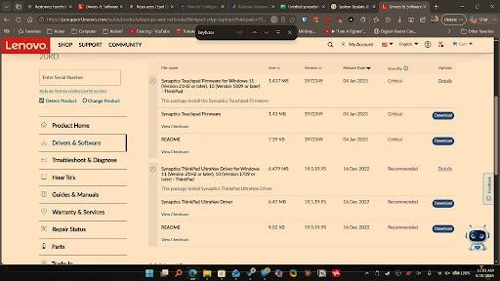
which to download?

You are currently under the Mouse, Touchpad and Pen section in your screenshot. None of those are for the keys.
How to get to the correct download:
Scroll further down the left side or main list to find the Software and Utilities category. Click to expand Software and Utilities.
Look for Lenovo Hotkey Features Integration (or Lenovo Base Utility). Click the blue Download button next to it.
Once downloaded, open and run the .exe file, then reboot your laptop.
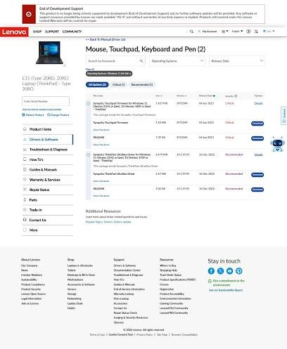
?
You are currently looking at a filtered list containing only Mouse, Touchpad, Keyboard and Pen items.

Option 1: Get it from the Microsoft Store (Easiest)
Since Lenovo limits website downloads for older models, the simplest fix is through the Store: Open your Windows Start Menu and click Microsoft Store.
Search for Lenovo Hotkeys. Click Get or Install.
Option 2: Fix the Filter on the Lenovo Website
To view the correct driver download on your screen:
Click << Back To Manual Driver List at the top of the webpage (above "Mouse, Touchpad, Keyboard and Pen (2)").
In the full list of categories that appears, look for Software and Utilities.
Expand Software and Utilities and download Lenovo Hotkey Features Integration (or Lenovo Base Utility).

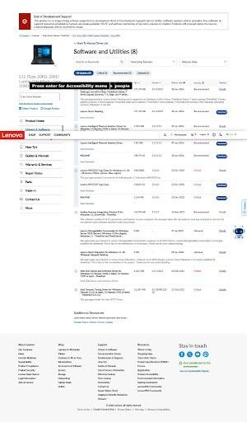
??
That's the exact section!
Look near the bottom of that list for Hotkey Features Integration (Version 9) for Windows 11, 10 (64-bit) - ThinkPad.
What to do:
Click on Hotkey Features Integration (Version 9) to expand it.
Click the blue Download button right next to it (it's a ~14.17 MB file). Once downloaded, open and run the .exe file to complete the installation. Restart your laptop so Windows loads the driver.
Once rebooted, pressing F9 will open Settings and F10 will toggle Bluetooth like it used to.

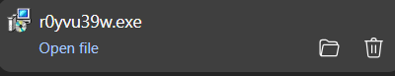

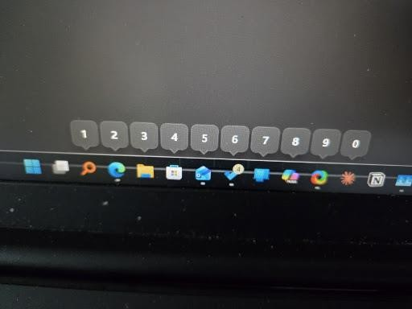

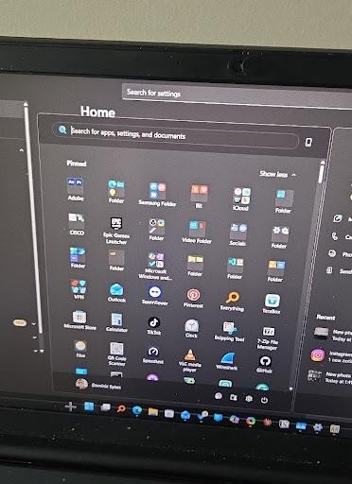

Powertoys installed but when I hit windows button it does that instead of second pic? That overlay with the numbered badges is PowerToys' Shortcut Guide triggering because the Windows key is being held down slightly too long (or the trigger time is set short). The second photo shows the standard Windows 11 Start Menu, which only pops up on a quick tap of the Windows key.

How to Fix It in PowerToys Settings
Open PowerToys.
Select Shortcut Guide from the left sidebar.
Toggle Enable Shortcut Guide to Off if you don't use the overlay.

Alternatively, if you want to keep it, increase the Open delay (ms) slider (e.g., to 1000 ms) so it won't trigger during a normal Windows key press.

How to Get PowerToys Run Instead

If you installed PowerToys expecting a fast search menu like the second image (PowerToys Run), press Alt + Space on your keyboard.

